*Session 17: Assignment 1*

**Problem Statement 1:**

1. Read the text file, and create a tupled rdd.

2. Find the count of total number of rows present.

3. What is the distinct number of subjects present in the entire school

4. What is the count of the number of students in the school, whose name is Mathew and

marks is 55

**Problem Statement 2:**

1. What is the count of students per grade in the school?

2. Find the average of each student (Note - Mathew is grade-1, is different from Mathew in

some other grade!)

3. What is the average score of students in each subject across all grades?

4. What is the average score of students in each subject per grade?

5. For all students in grade-2, how many have average score greater than 50?

**Problem Statement 3:**

Are there any students in the college that satisfy the below criteria :

1. Average score per student_name across all grades is same as average score per

student_name per grade

Hint - Use Intersection Property.

**Solution Statement 1:**

**The DataSet file**

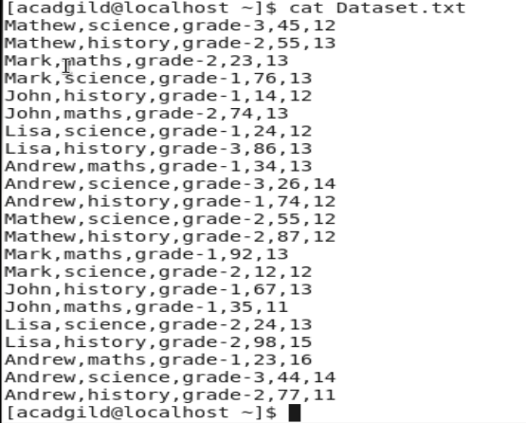

1. Read the text file, and create a tupled rdd.

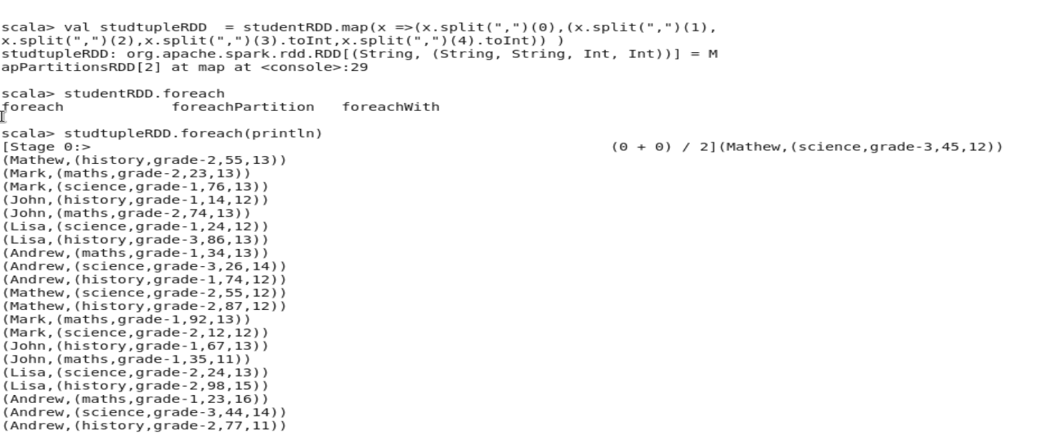

2. Find the count of total number of rows present.

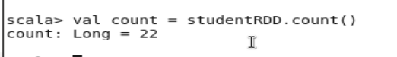

3. What is the distinct number of subjects present in the entire school

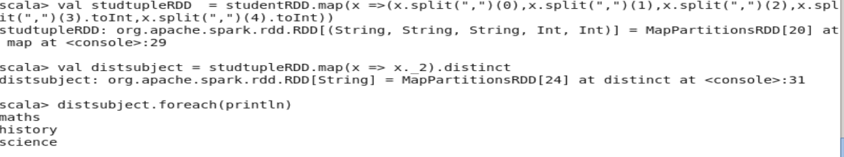

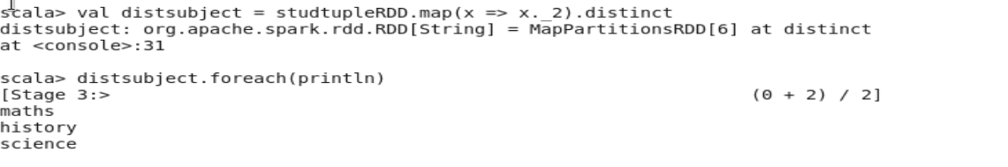



4. What is the count of the number of students in the school, whose name is Mathew and

marks is 55



**Solution 2:**

1. What is the count of students per grade in the school?

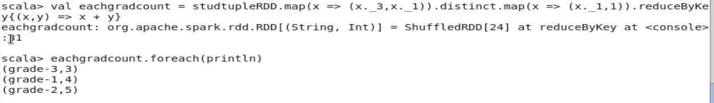

2. Find the average of each student (Note - Mathew is grade-1, is different from Mathew in

some other grade!)

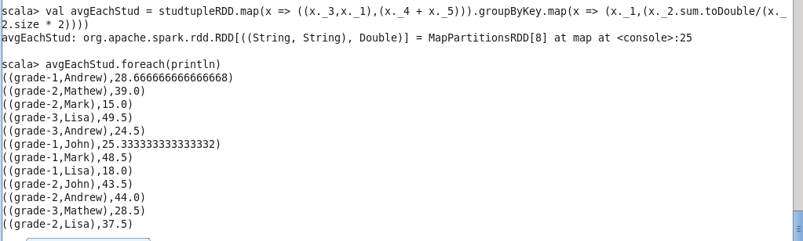

3. What is the average score of students in each subject across all grades?

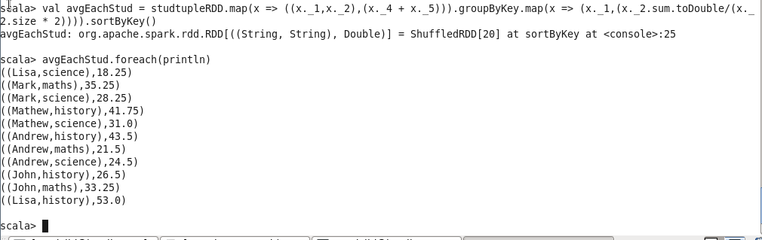

4. What is the average score of students in each subject per grade?

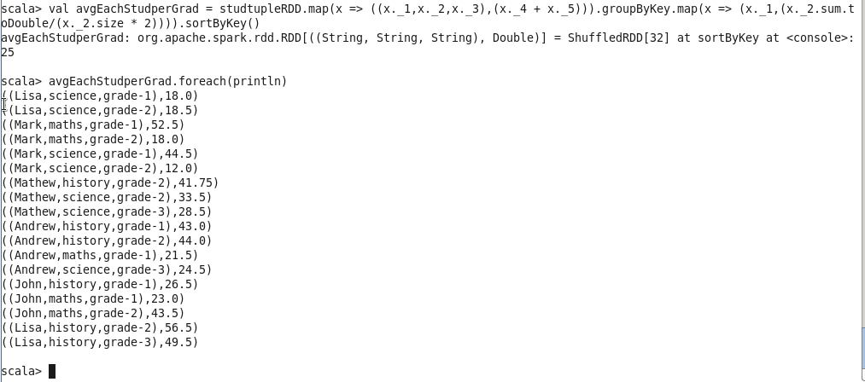

5. For all students in grade-2, how many have average score greater than 50?

